- Now we are going to add Bean shell post processor like below. 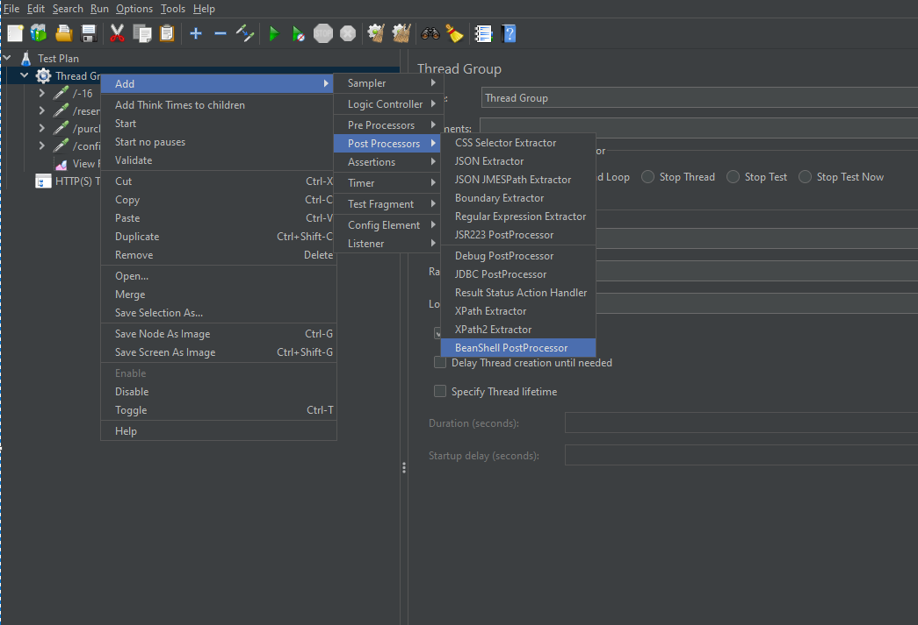
- In JMeter, it will provide few variables that we need to access.
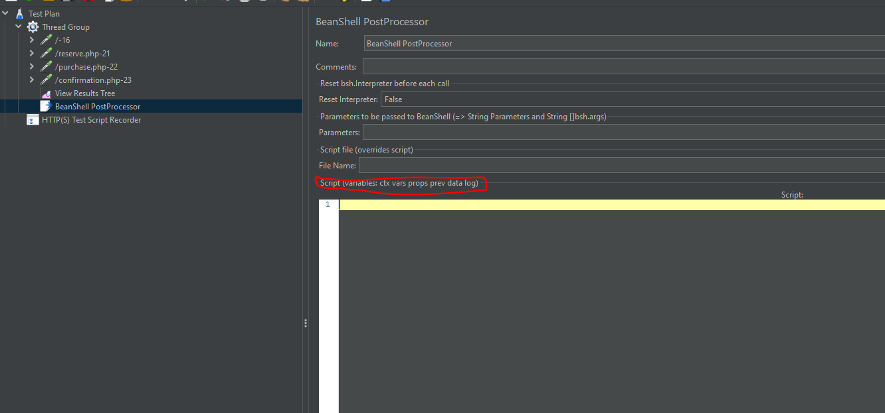

Here ctx -> we have already discussed with ctx in last script
Vars -> It is nothing but variable, if we have 5 threads in our test plan and
we have created a variable under one thread then that variable can be
accessible inside of that thread only
props -> It is nothing but property, if we have 5 threads in our test plan and
we have created a variable under test plan then that variable can be
accessible inside of any thread group
Difference : Variable can be created under thread group and property can be created

Under test plan.
Prev: No need to create this prev variable we can just simply use this and we have few

methods inside of it we can use that to fetch last sampler result.
- Below is the sample example
